Glossary

Special Friends
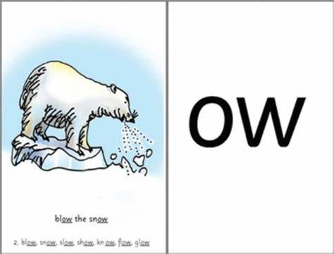
Special friends are a combination of two or three letters representing one sound, e.g. ow, ck, ay, igh, oa.

Fred Talk
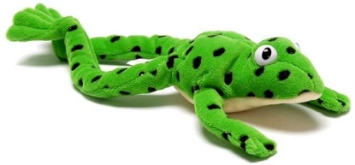
Fred the Frog helps children read and spell. He can say the sounds in words, but he can’t say the whole word, so children have to help him.
To help children read, Fred (the teacher) says the sounds and then children say the word.
For example, Fred says c-a-t, children say cat, Fred says l-igh-t, children say light.
Teachers are encouraged to use Fred Talk through the day, so children learn to blend sounds.
For example:
Play Simon Says: Put your hands on your h-ea-d/ f-oo-t/ kn-ee.
Put on your c-oa-t/ h-a-t/ s-c-ar-f.
Set the table with a b-ow-l/ f-or-k/ s-p-oo-n.

Fred in your head
Once children can sound out a word, we teach them to say the sounds silently in their heads.
We show them how to do this by:
1. whispering the sounds and then saying the whole word;
2. mouthing the sounds silently and then saying the whole word;
3. saying the whole word straight away.

Perfect pencil grip
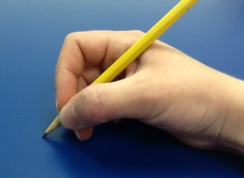
Children sit at a table to write.
They hold up a pencil in a tripod pencil grip with the non-writing hand flat holding their paper. Sometimes we also call this a ‘snappy grip.’

