Supporting Early Spelling

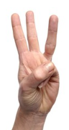
Fred Fingers

- Encourage your child to use Fred Fingers to spell words

- Ask your child to say the sounds in the word as they press the sounds onto their fingers

- Ask your child to then write the letters – if they get stuck, say the sounds again

- Praise your child for spelling using the sounds they know, even if their handwriting is not perfect.

