Helpful Tips

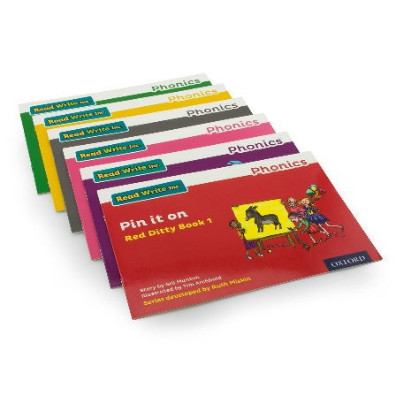
When appropriate, your child will bring home a Storybook matched to the sounds and words they know – a decodable book – so they should be able to read all the words.

Please avoid saying, “This book is too easy for you!” but instead say “I love how well you can read this book!”
Instead say “I love how well you can read this book!”

‘Special Friends’, ‘Fred Talk’, read the word
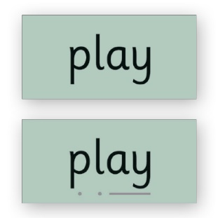
Remind your child to read words using ‘Special Friends, Fred Talk, read the word’
For example ‘ship’: spot the ‘sh’, then Fred Talk and blend to read the word e.g. sh, sh-i-p, ship.

Red Words

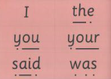
Red Words are also known as common exception or tricky words. They occur in stories regularly (said, what, where) but have unusual letter combinations (‘ai’ in the word ‘said’ makes the sound ‘e’).

Remind your child not to use Fred Talk to read Red Words but instead to ‘stop and spot the tricky sound first’.
Tell them the word if you need to.

Read the same book again and again

Children love reading the same book again and again. Their reading becomes speedier and they understand what they are reading.

- Encourage your child to read words using ‘Fred in your head’ (see glossary)
- Show your child how to read the story in a storyteller voice
- Share your enjoyment of the story when they read it again and again.

Sharing picture books

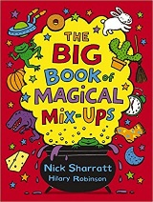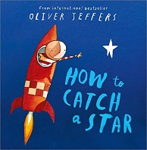
One of the most important things you can do as a parent at home is read to your child.

Loving stories is important because children who love stories want to read stories for themselves.

Children who read a lot and listen to adults read a lot become better readers.

Please also see page titled, ‘Reading at Hone’

