Reading at Home

Whilst learning Set 1 sounds, your child will bring home worksheets to practise reading sounds that they have already been taught in school. Please do not use letter names. Your child has been taught to read using sounds.
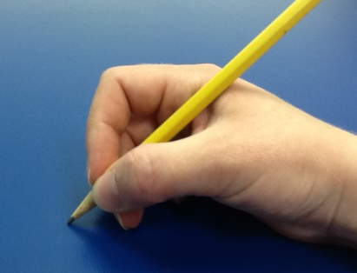
Support your child by saying the sound and the handwriting phrase as they write.
Your child should be encouraged to hold their pencil using the correct pencil grip. They may call this a ‘snappy grip’ or a ‘tripod grip’.

For a list of the Set 1 sounds handwriting phrases, please see document attached.

Take home storybooks

Every week your child will now take home two Read, Write Inc. reading books:

1. A Read, Write, Inc. book that they have read with their RWI teacher during lesson time.
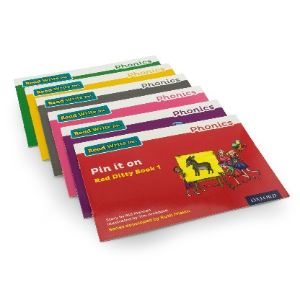
Children have read the new book in their Read, Write Inc. lessons this week and are now ready to read it to you. It is important that you read this book with your child several times over the week as this will help your child to read the book with fluency and expression. It will also help to increase the number of words in their long term memory. Children can read words that are in their long term memory quickly because they just know them.

At the back of the book you will find a page called Questions to talk about. Please use these questions to help you talk about what is happening in the book as it is important that your child can not only read the book fluently but can also understand and talk about what happened.

There is also a Speed Words game which you can play with your child. Point to the words as your child reads the words quickly. If your child needs to sound out (Fred talk) the words then he/she needs more practice.

2. A new Read, Write, Inc. Book Bag Book.

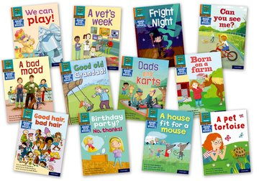
This is a new and exciting book for your child to read to you that they have not read during lesson time. A Book Bag Book from an earlier, and simpler, colour band will have been selected to encourage your child to read independently to you. As this is a new book that they have not seen before, they may need your support to help them to sound out any unfamiliar words as they read.

