Speed Sounds Lessons

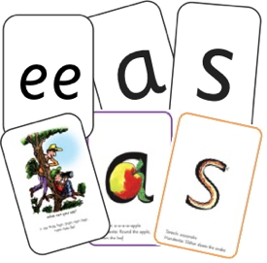At every stage of the RWI programme, children participate in a daily Speed Sounds lesson. Which sound they learn depends on what is most appropriate to their stage of development.

Here is an overview of the Speed Sounds lesson structure:

Set 1 Sounds

Using RWI, we make learning to read easy for children because we start by teaching them just one way of reading and writing every sound.
We teach Set 1 sounds first.
Set 1 Sounds are taught in the following order together with phrases to help children form the letters correctly and instantly recognise sounds ready for blending.
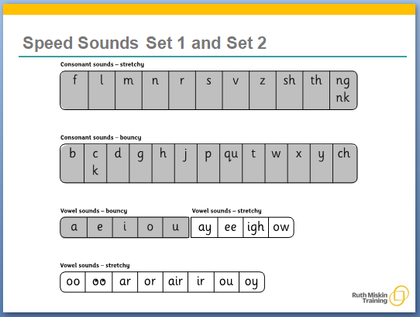
We teach using pure sounds.
We pronounce the sounds clearly, using pure sounds (‘m’ not’ muh’, ’s’ not ‘suh’, etc.) so that your child will be able to blend the sounds together to make words more easily.

Please support your child by saying sounds – not letter names – to read words.

Watch the ‘how to say the sounds’ parent film on http://www.ruthmiskin.com/en/parents/

Also watch the ‘Reading the stretchy sounds with your child’, ‘Reading the bouncy sounds with your child’ and ‘Reading the digraphs with your child’ parent films on http://www.ruthmiskin.com/en/parents/ to see how to teach Set 1 sounds.

Set 2 Sounds

The children are then taught Set 2 Sounds - the long vowels.

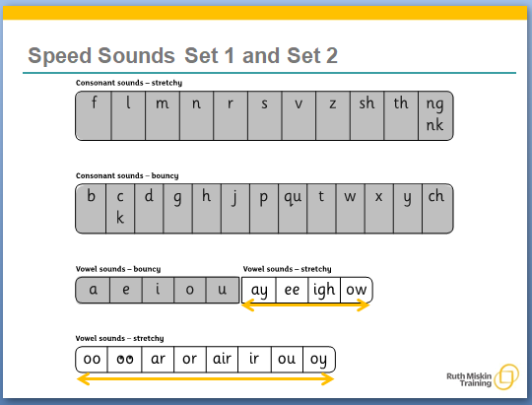
Set 3 Sounds

When children are very confident with all of Set 1 and Set 2 they are taught Set 3 Sounds.

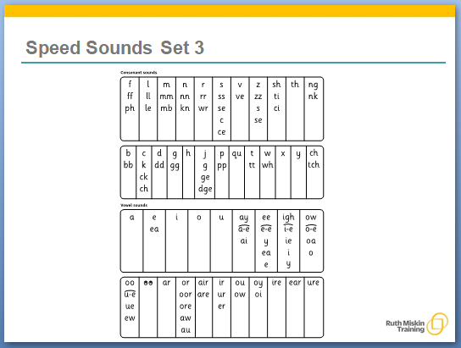

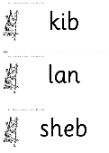
Nonsense Words
Nonsense words, also named Alien words, are used to check that your child can read any word. They are introduced to children when they are coming to the end of Set 1 Speed Sounds. Children are able to use their sound recognition skills to read these words that do not make sense. We say they are taken from an ‘alien language’

