Admissions Policy 2024-25

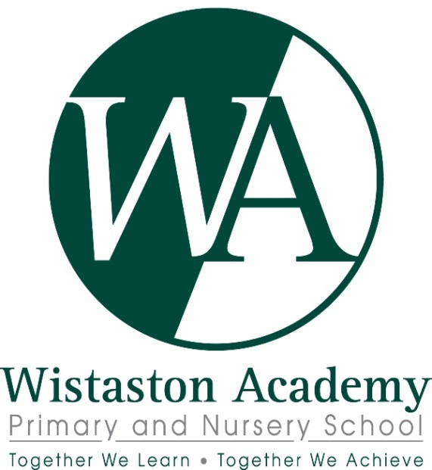

Policy Author | Dominique Griffiths, Principal
Responsible Governor’s Committee | Business, Finance and HR
Date Reviewed | September 2022
Frequency of Review | Review annually and in the light of changes to legislation or operating experience

Admissions Policy for Academic Year 2024/25
Wistaston Academy is an Academy Trust and the Governing Body is the admissions authority. The admissions policy has been designed to comply with the Schools Admissions Code 2021 and all relevant legislation, including that on infant class sizes and equal opportunities.
Admissions to the Reception Year
Subject to the criteria set out below, children will be admitted in the September following their fourth birthday. The academy has an agreed admission number (the published admission number or PAN) of 60 pupils for entry in reception. The academy will accordingly admit up to 60 pupils. Where a child is one of a multiple birth it may be necessary to offer places over the published admission number. This is to ensure that, as far as possible, siblings (i.e. twins, triplets or children from other multiple births) can attend the Academy.
Places will be allocated by the Governing Body on the basis of applications received through the Cheshire East admissions system. This allows parents/guardians to apply for entry to any Cheshire East primary school by means of the Cheshire East Primary School Common Application Form (CAF) available in the ‘Applying for school Places’ document published by Cheshire East Council (CEC) and on-line via the CEC website. Late applicants may be disadvantaged but are dealt with through the ‘coordinated Scheme’ on the Cheshire East website.
The school will offer places on a full-time basis from the start of the Autumn Term.
Late applications for September admissions into Reception Year
To make a late application please ring 0300 123 5012 or complete a form that can be found in the back of the booklet Applying for School Places 2024-25.
“In-Year” Admissions
In-year admissions will be handled by the academy. Applications should be made via the Cheshire East website:
https://www.cheshireeast.gov.uk/schools/admissions/admissions.aspx
Exceeding the Academy’s PAN
The academy may decide to exceed the PAN in Key Stage 2. However, this will be dependent on the current class sizes and whether admitting extra pupils would be detrimental to those already on roll. We will not exceed our PAN for Foundation and KS1 applications unless there are exceptional and permitted reasons.
Oversubscription Criteria for all types of admissions
Where more applications are received than there are places available, after children with Education, Health and Care (EHC) plans, priority for admission will be based on the Local Authority’s published oversubscription criteria.
Once children with Education, Health and Care (EHC) Plans naming Wistaston Academy have been admitted then places are allocated in accordance with the order of the following oversubscription rules:
1. ‘Looked after children’ and children who were previously ‘looked after’. A ‘looked after child’ is a child who is in the care of a local authority or being provided with accommodation by a local authority (as defined in section 22of the Children Act 1989) at the time of making the application to school. Children previously ‘looked after’ are children who were looked after as defined above, but immediately after being ‘looked after’ became subject to an adoption, child arrangement, or special guardianship order. An adoption order is an order under section 46 of the Adoption and Children act 2002. A ‘child arrangement order’ is an order settling the arrangements to be made as to the person with whom the child is to live under section 8 of the Children Act 1989. Section 14A of the Children Act 1989 defines a ‘special guardianship order’ as an order appointing one or more individuals to be a child’s special guardian (or special guardians). This includes children who appear to (in the view of Cheshire East) have been in state care outside of England and ceased to be in state care as a result of being adopted.
2. Siblings - pupils with brothers or sisters, step-brothers or step-sisters, foster brother or sisters, half-brother or half-sisters, adopted brothers or adopted sisters living together as part of one household, already attending the preferred school (in years reception through to year 6) and expected to continue at the school in the following school year (i.e. at the time of admission).
3. Children attending the Wistaston Academy Nursery – any child attending the Nursery during the admission period preceding their year of entry to Reception.
4. Children resident within the designated catchment area of the school – children will be classed within this criterion if they and their parents/carers are resident within the area served by the school.
5. Pupils living nearest to the school – measured using the National Land and Property Gazetteer (NLPG) which measures straight line distances in miles from the school’s coordinate point to the point of the residence’s coordinate point. An admissions panel including two governors not employed by the academy will apply the oversubscription criteria.
Tie-Breaker
If there are more applicants than there are places remaining within a particular category, and where there are siblings or there is no difference in distance from home to the Academy for two or more children, random allocation will be used to allocate the final available place(s).
Fair Access Protocol
The academy participates in Cheshire East Local Authority Fair Access protocol.
Right of Appeal
In the event of an unsuccessful application, parents have the right to appeal to an independent appeals panel against non-admission. Appeal forms can be requested from the academy and appeals can be lodged up to 20 school days from the date of the offer letter. Where an in-year application and subsequent appeal are unsuccessful the Admissions Authority will not consider a repeat application within the same academic year unless there has been a relevant and significant change of circumstances relating to the application, or a place has become available in school.
The academy will hold a waiting list until at least the end of the Autumn term for the Reception intake. This will be held in criteria order and not on a first-come first-served basis. Once the Waiting List has ended at the end of the Autumn term, parents are asked to keep in touch with the school to find out if a place has become available.
Further information can be found in the ‘Applying for school places’ document produced by Cheshire East.

